**AIRLINE RESERVATION SYSTEM UML DIAGRAMS**

**G.Lahari Smitha**

**(192011076)**

**1.USE CASE DIAGRAM**

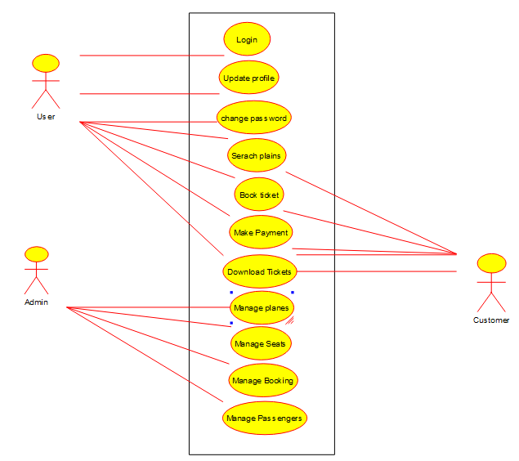

**2.SEQUENCE DIAGRAM**

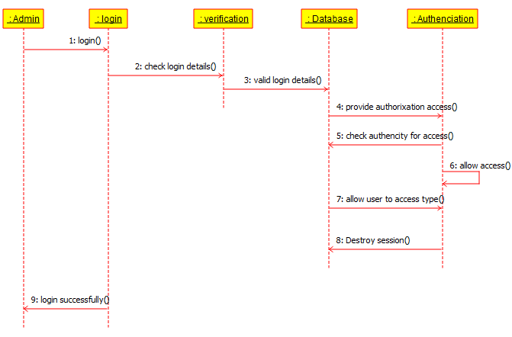

**3.CLASS DIAGRAM**

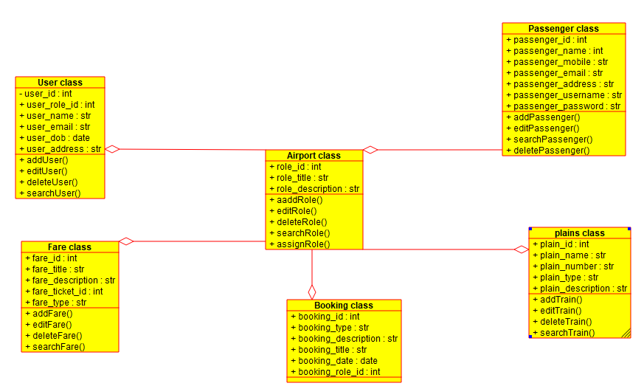

**ACTIVITY DIAGRAM**

